SIT772 Assessment 1

Student Name: Dhananjay Pandya

Student Number: 21820294

# Question 1

## Exercise 1

### Entities & Attributes

1. Artwork - Sculpture, Painting etc.
   * Attributes: Barcode, Title, Description, Artist
2. Artist
   * Attributes: Name, Address, Contact Number, Artwork(s)
3. Visitor
   * Attributes: Name, Address, Phone Number, Barcode ID, Nominated Artwork(s)
4. Votes
   * Attributes: Visitor ID, Artwork Barcode

### Relationships

1. Relationship between Artist and Artwork: One artist may create more than one artwork for the exhibition (could be either One to Many/One to One)
2. Relationship between Visitor and their nominated Artwork: One to One or One to Many

## Exercise 2

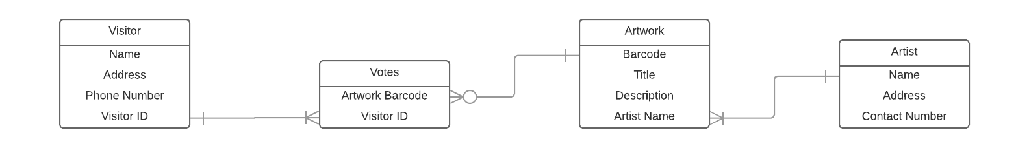

## Exercise 3

CREATE TABLE artist

(name CHAR(15) NOT NULL,

address VARCHAR(280) NOT NULL,

contactNumber NUMBER(10) NOT NULL,

PRIMARY KEY (name));

CREATE TABLE artwork

(barcode NUMBER(8) NOT NULL,  
title CHAR(15) NOT NULL,

description VARCHAR(280) NOT NULL,

artist CHAR(15) NOT NULL,

PRIMARY KEY (barcode),

FOREIGN KEY (artist) REFERENCES artist(name));

CREATE TABLE visitor

(name CHAR(15) NOT NULL,

address VARCHAR(280) NOT NULL,

phoneNumber NUMBER(10) NOT NULL,

visitorID NUMBER(8) NOT NULL,

PRIMARY KEY (visitorID));

CREATE TABLE votes

(barcode NUMBER(8) NOT NULL,

visitorID NUMBER(8) NOT NULL,

FOREIGN KEY (barcode) REFERENCES artwork(barcode),

FOREIGN KEY (visitorID) REFERENCES visitor(visitorID));

# Question 2

## Exercise 1

CREATE TABLE student1

(student_ID NUMBER(5) NOT NULL,

student_fName VARCHAR(15) NOT NULL,

student_lName VARCHAR(15) NOT NULL,

PRIMARY KEY(student_ID));

INSERT INTO student1

VALUES (10001,'John','Smith');

INSERT INTO student1

VALUES (10002,'Dave','Franklin');

INSERT INTO student1

VALUES (10003,'Febby','Johns');

INSERT INTO student1

VALUES (10004,'Mary','Gibson');

INSERT INTO student1

VALUES (10005,'Glory','Anson');

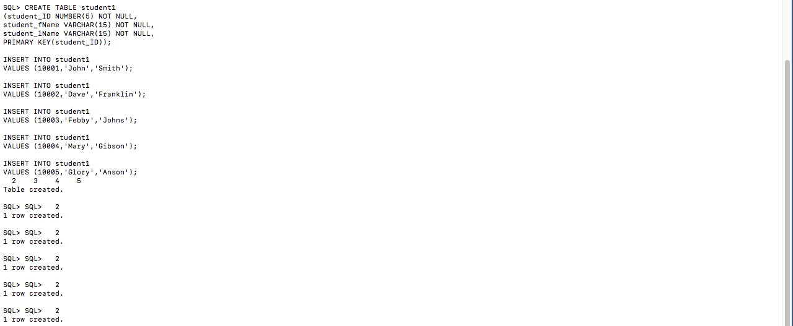

CREATE TABLE course

(course_ID CHAR(6) NOT NULL,

course VARCHAR(50) NOT NULL,  
location VARCHAR(15) NOT NULL,  
PRIMARY KEY (course_ID));

INSERT INTO course  
VALUES ('SIT772','Database','Burwood');

INSERT INTO course  
VALUES ('SIT774','IT security','Burwood');

INSERT INTO course  
VALUES ('SIT775','Software Development','Geelong');

INSERT INTO course  
VALUES ('SIT712','Project Management','Burwood');

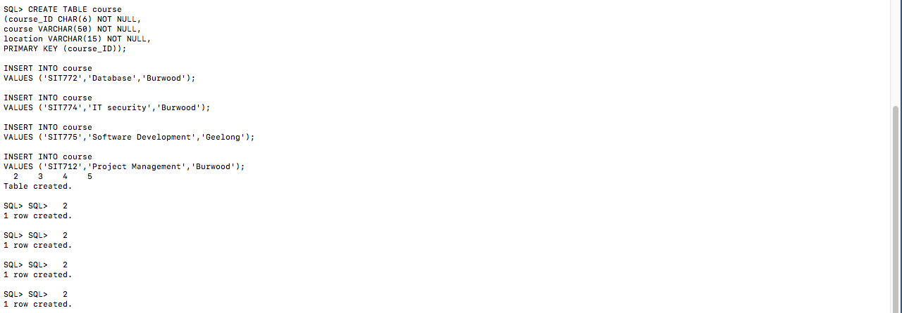

CREATE TABLE student2

(student_ID NUMBER(5) NOT NULL,

course_ID CHAR(6) NOT NULL,

year_joined NUMBER(4) NOT NULL,

FOREIGN KEY (student_ID) REFERENCES student1(student_ID),

FOREIGN KEY (course_ID) REFERENCES course(course_ID));

INSERT INTO student2

VALUES (10001,'SIT772',2016);

INSERT INTO student2

VALUES (10002,'SIT774',2015);

INSERT INTO student2

VALUES (10003,'SIT775',2017);

INSERT INTO student2

VALUES (10004,'SIT712',2016);

INSERT INTO student2

VALUES (10005,'SIT772',2017);

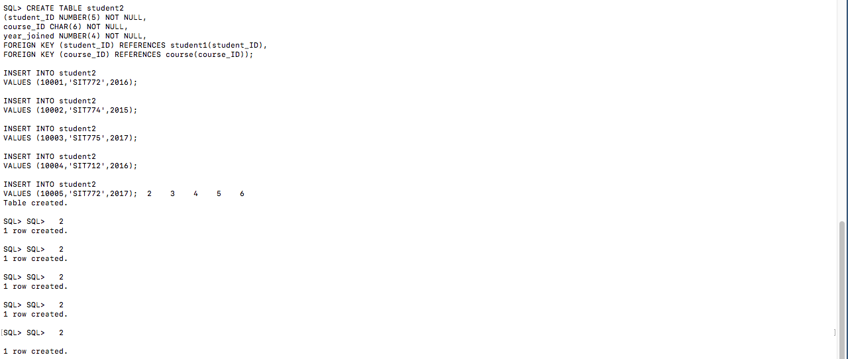

## Exercise 2

SELECT student1.student_ID, student1.student_fName, student1.student_lName

FROM student1

INNER JOIN student2 ON student1.student_ID = student2.student_ID

WHERE year_joined >= 2016;

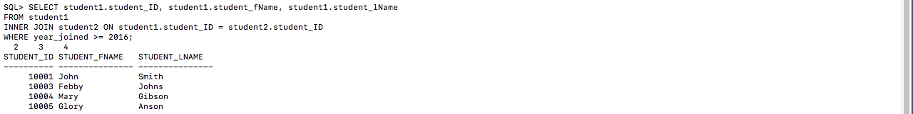

## Exercise 3

SELECT *

FROM student1

WHERE LOWER(student_fName) LIKE '%a%'

OR LOWER(student_lName) LIKE '%a%';

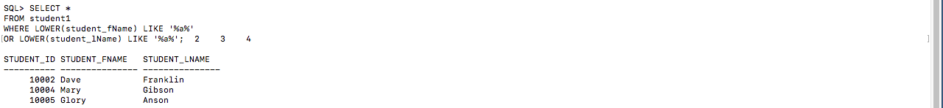

## Exercise 4

SELECT student1.student_ID, student1.student_fName, student1.student_lName

FROM student1

INNER JOIN student2 ON student1.student_ID = student2.student_ID

INNER JOIN course ON course.course_ID = student2.course_ID

WHERE course.location='Burwood';

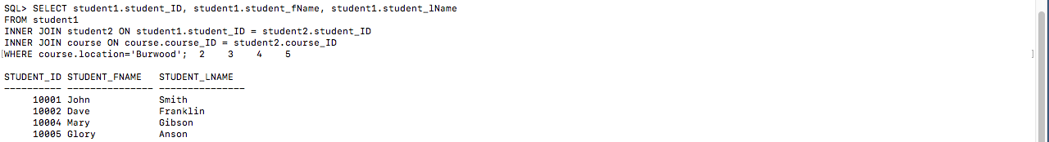

## Exercise 5

SELECT student1.student_ID, student1.student_fName, student1.student_lName

FROM student1

INNER JOIN student2 ON student1.student_ID = student2.student_ID

INNER JOIN course ON course.course_ID = student2.course_ID

WHERE course.location='Geelong'

OR course.course = 'Database';

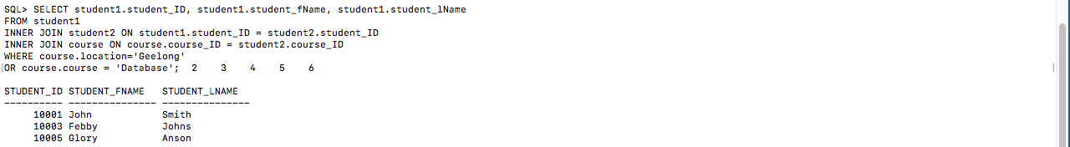

# Question 3

## Exercise 1

### Relational schema:

SALES(CUS_ID,Name,ORD_NO,ORD_Date,PROD_ID,Description,Qty_Ord)

### Dependency diagram:

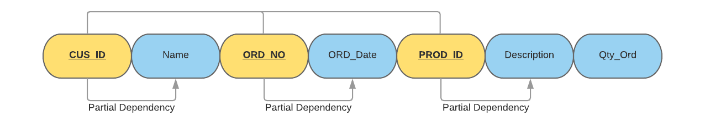

## Exercise 2

### Relational schema:

CUSTOMER(CUS_ID,Name)

### Dependency diagram:

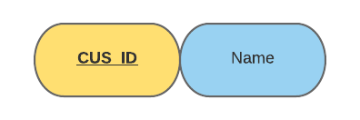

### Normal form:

3NF

### Relational schema:

ORDER(ORD_NO,ORD_Date)

### Dependency diagram:

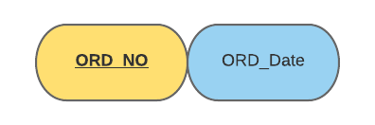

### Normal form:

3NF

### Relational schema:

PRODUCT(PROD_ID,Description)

### Dependency diagram:

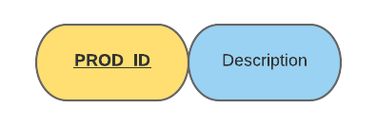

### Normal form:

3NF

### Relational schema:

CUSTOMER_ORDER_PRODUCT(*CUS_ID,ORD_NO,PROD_ID,*Qty_Ord)

### Dependency diagram:

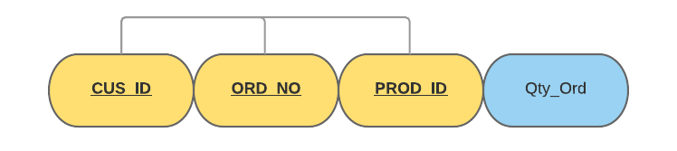

### Normal form:

3NF

## Exercise 3

Same as above solution to Exercise 2 – No changes as there were no transitive dependencies found.

## Exercise 4

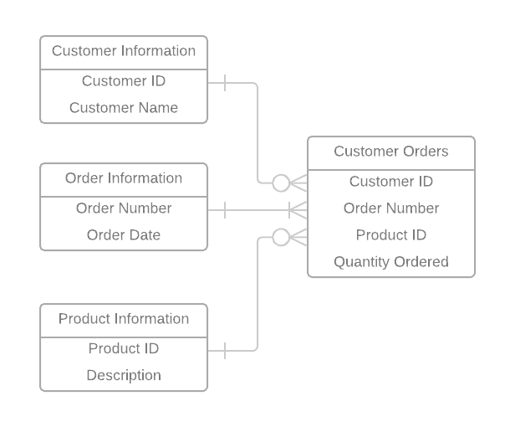

# Question 4

## Exercise 1

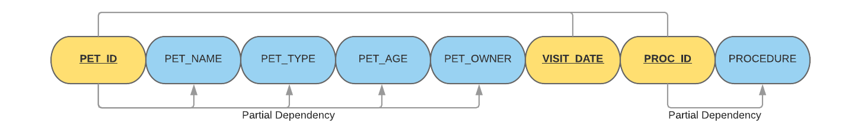

|  |  |  |
| --- | --- | --- |
| **PET ID** | **VISIT DATE** | **PROC_ID** |
| 246 | 13-Jan-02 | 01 |
| 246 | 27-Mar-02 | 10 |
| 246 | 2-Apr-02 | 05 |
| 298 | 21-Jan-02 | 08 |
| 298 | 10-Mar-02 | 05 |
| 341 | 23-Jan-01 | 01 |
| 341 | 13-Jan-02 | 01 |
| 519 | 30-Apr-02 | 20 |
| 519 | 30-Apr-02 | 12 |

|  |  |  |  |  |
| --- | --- | --- | --- | --- |
| **PET ID** | PET NAME | PET TYPE | PET AGE | OWNER |
| 246 | ROVER | DOG | 12 | SAM COOK |
| 298 | SPOT | DOG | 2 | TERRY KIM |
| 341 | MORRIS | CAT | 4 | SAM COOK |
| 519 | TWEEDY | BIRD | 2 | TERRY KIM |

|  |  |
| --- | --- |
| **PROC_ID** | PROCEDURE |
| 01 | RABIES VACCINATION |
| 10 | EXAMINE and TREAT WOUND |
| 05 | HEART WORM TEST |
| 08 | TETANUS VACCINATION |
| 20 | ANNUAL CHECK UP |
| 12 | EYE WASH |

## Exercise 2

CREATE TABLE petVetVisits

(petID SMALLINT NOT NULL,

visitDate DATE NOT NULL,

procID SMALLINT NOT NULL,

PRIMARY KEY (petID,visitDate,procID));

INSERT INTO petVetVisits VALUES (246,'13-Jan-2002',01);

INSERT INTO petVetVisits VALUES (246,’27-Mar-2002’,10);

INSERT INTO petVetVisits VALUES (246,’02-Apr-2002’,05);

INSERT INTO petVetVisits VALUES (298,’21-Jan-2002’,08);

INSERT INTO petVetVisits VALUES (298,’10-Mar-2002’,05);

INSERT INTO petVetVisits VALUES (341,’23-Jan-2001’,01);

INSERT INTO petVetVisits VALUES (341,’13-Jan-2002’,01);

INSERT INTO petVetVisits VALUES (519,’30-Apr-2002’,20);

INSERT INTO petVetVisits VALUES (519,’30-Apr-2002’,12);

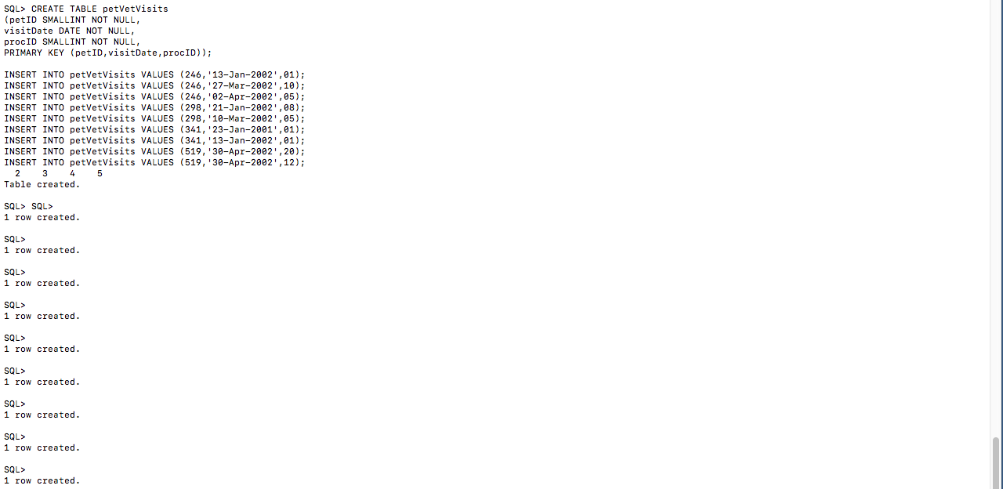

CREATE TABLE pets

(petID SMALLINT NOT NULL,

petName VARCHAR(15) NOT NULL,

petType VARCHAR(15) NOT NULL,

petAge SMALLINT NOT NULL,

owner VARCHAR(25) NOT NULL,

PRIMARY KEY (petID));

INSERT INTO pets VALUES (246,'ROVER','DOG',12,'SAM COOK');

INSERT INTO pets VALUES (298,'SPOT','DOG',2,'TERRY KIM');

INSERT INTO pets VALUES (341,'MORRIS','CAT',4,'SAM COOK');

INSERT INTO pets VALUES (519,'TWEEDY','BIRD',2,'TERRY KIM');

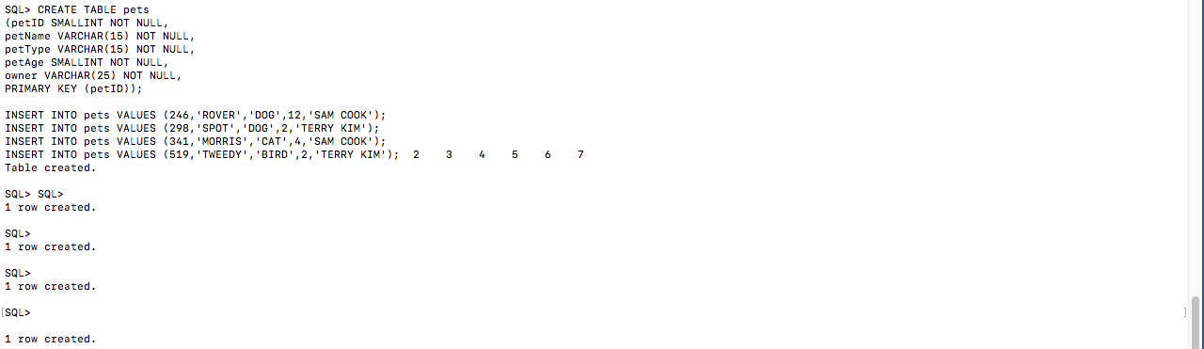

CREATE TABLE procedures

(procID SMALLINT NOT NULL,

procedure VARCHAR(100) NOT NULL,

PRIMARY KEY (procID));

INSERT INTO procedures VALUES (01,'RABIES VACCINATION');

INSERT INTO procedures VALUES (10,'EXAMINE and TREAT WOUND');

INSERT INTO procedures VALUES (05,'HEART WORM TEST');

INSERT INTO procedures VALUES (08,'TETANUS VACCINATION');

INSERT INTO procedures VALUES (20,'ANNUAL CHECK UP');

INSERT INTO procedures VALUES (12,'EYE WASH');

